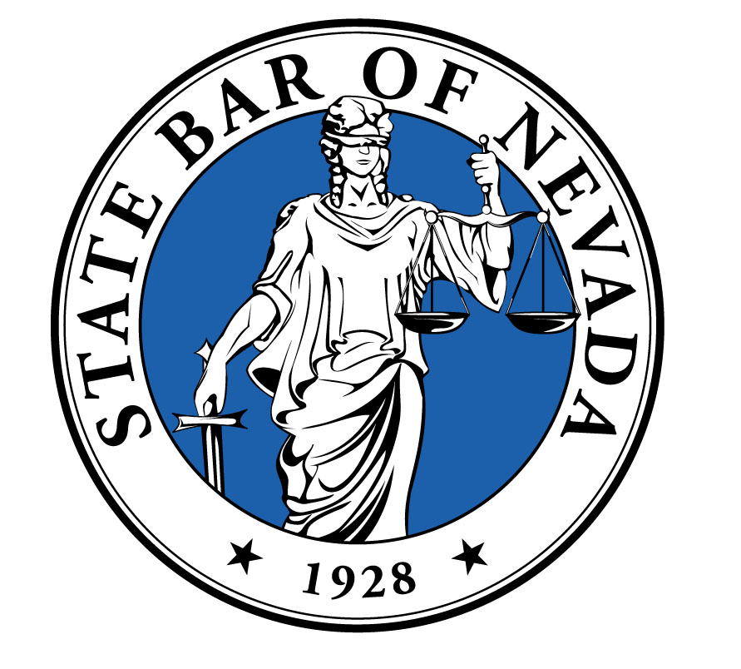
STATE BAR OF NEVADA
For Administrator Use Only:

Ad. #: __________________

Date Rec’d _____________

District_________________

Type of Ad______________

Ackn. Letter Sent_________

Fwd. to Committee________

Next Action:_____________
MANDATORY ADVERTISING FILING FORM
PURSUANT TO RPC 7.2A
(updated 12/07)

 | Effective September 1, 2007, Rule of Professional Conduct (“RPC”) 7.2A (Advertising Filing Requirements) requires that a lawyer file with the state bar a copy or recording of an advertisement or written or recorded communication within 15 days of first dissemination along with a form supplied by the State Bar, except those advertisements exempt pursuant to Advertising Committee Rule (“ACR”) 2(o). If desired, advance opinion may be obtained pursuant to RPC 7.2(B) by submitting a copy of the advertisement with an application form and the fee required by ACR 8. If an advance opinion is requested, the committee shall issue a written opinion within 30 days of submission.
INSTRUCTIONS FOR SUBMISSION OF THE APPLICATION
- Complete Filing Form in full. Please print or type. Application may be reproduced.  - A separate Filing Form must be submitted for each advertisement or writing.  - Attached advertisement or writing.  - Each form regarding a written, recorded or other electronic media advertisement or solicitation shall be accompanied by a copy of the advertisement or solicitation.  - An audio or video advertisement shall be accompanied by a recording of the advertisement and a written transcript of the recording.  - Any public media advertisement or solicitation communication in a non-English language shall be accompanied by a complete, accurate English translation in addition to the copy of the script in the same language of which the advertisement is recorded in.  - Audio and video recordings shall be submitted in DVD, CD or e-mail format. |  |  |  |  | - This form and its attachments may be submitted in either physical or digital format to:  Attn.: Luisa Cota,  Advertising Administrator  State Bar of Nevada  600 East Charleston Blvd.  Las Vegas, NV 89104  EMAIL: Luisac@nvbar.org  A separate Filing Form must be submitted for each advertisement or writing and only one (1) copy of the advertisement is necessary.  For questions concerning filing requirements visit www.nvbar.org, Advertising Section or call 702-382-2200, Ext. 418.
Lawyer: ____________________________________________________ Bar No. ________________

Firm: _______________________________________________________________________________
Firm’s Principal Office Address: __________________________________________________________
____________________________________________________________________________________
Phone: ___________________ |  |  | Fax: _____________________ |  |  |  | E-mail: _____________________
Nature of advertisement or written solicitation:
A. ________ Letter |  |  | C. ________ Newspaper/Periodical |  |  |  | E. ________ Billboards and other signs
B. ________ Telephone Directory |  |  | D. ________ Television/Radio |  |  |  | F. ________ Other, explain:
State the date the advertisement or writing was first disseminated or mailed: __________________
State where the advertisement is disseminated (i.e. which newspapers, telephone directories, periodicals, television stations, there may be more than one): __________________________________________ ________________________________________
____________________________________________________________________________________
Does the advertisement or writing disclose or allude to a specific fee, range of fees, or that the lawyer or law firm will render fees on a contingent fee basis? Yes ________ No ________

(Form continued on back)

Does the advertisement or writing disclose the existence of an office other than the firm’s principal office? Yes________ No ________
Does the advertisement or writing designate or allude to one or more specific areas of practice?
Yes________ No ________
Identify any lawyers depicted in the advertisement: ________________________________________

___________________________________________________________________________________
Identify any actual employees of the lawyer/firm depicted in the advertisement with job title:
___________________________________________________________________________________

___________________________________________________________________________________
Identify any actual clients depicted in the advertisement along with such clients’ addresses and phone numbers:______________________________________________________________________

__________________________________________________________________________________

Identify any actors and/or spokesperson used in the advertisement:__________________________

___________________________________________________________________________________

Additional or Substantiating information: __________________________________________________________________________________

___________________________________________________________________________________

Note: the Advertising Review Committee may request substantiation of any statement or representation made in the submitted advertisement.
ATTEST: I HAVE REVIEWED THE ADVERTISEMENT OR WRITING SUBMITTED AS REQUIRED BY NEVADA RPC 7.2A. THE REPRESENTATIONS CONTAINED THEREIN AND THE INFORMATION IN THIS FORM ARE TRUE AND CORRECT.

_______________________________________________ _________________
Attorney Signature Date
FOR COMMITTEE USE ONLY

NO ACTION TAKEN  AFTER REVIEW  DATE_____________  BY_______________ |  | ADD’L INFORMATION REQUESTED  DATE ___________  BY _____________ |  | ADD’L INFORMATION REVIEWED/APPROVED  DATE___________  BY _____________ |  | REFERRED TO OFFICE OF BAR COUNSEL WITHIN 30 DAYS OF REVIEW  DATE _____________  BY________________

Please note that the Supreme Court amended the Rules of Professional Conduct (RPC) in ADKT No. 445 and the rules became effective on December 13, 2012. You may review the newly adopted and/or amended rules at:
http://www.nvbar.org/content/rules-professional-conduct-72-72a-and-73-amended

Below is a check list which is provided solely for your benefit and is intended to help you identify the most common problem areas with compliance in advertisements before filing. This form does not need to be returned with the mandatory advertising filing form. In addition, please be advised that following the checklist does not warrant that your advertisement is fully in compliance with the advertising rules since only the most common problems with the applicable advertising rules are listed. Please visit the following links for a full review of the Rules of Professional Conduct and Advertising Committee Rules concerning Lawyer Advertising:
http://nvbar.org/sites/default/files/lawyer_advertising_rules.pdf
http://nvbar.org/sites/default/files/Operating%20Rules%20FINAL.doc

Does not make any claims comparing your service to those of other attorneys which cannot be validated. If you have made comparative statements, does it include substantiating information with your filing form? (RPC 7.1(c))

Does not include any client testimonials or endorsements which would be either fictional or scripted? Can your testimonials be validated? (RPC 7.1(d))

Includes actor disclaimers for all actors portraying lawyers, clients, staff or used to depict a fictionalized event or scene? Have you identified any spokesmen as such? (RPC 7.2(b))

Identifies at least one lawyer responsible for the advertisement’s content. (RPC 7.2(c))

Includes a prominently displayed contingency fee disclaimer: “You may have to pay the
opposing party’s attorney fees and costs in the event of a loss.” If a contingency fee is
advertised in the event of a loss wherein the client may be liable for any costs of fees?
(RPC 7.2(e))

If referencing a specific fee or range of fees, include a disclaimer indicating any limiting conditions to the availability of the fee(s). (RPC 7.2(f))

Includes disclaimers for any statements regarding past results, such as, “this does not guarantee, warranty or predict the outcome of your case.” (RPC 7.2(i))

Includes “THIS IS AN ADVERTISEMENT” in red ink on all written solicitations? (RPC 7.3(c))

Did not use the word specialist or expert or any derivative thereof unless the advertising attorney has been certified a specialist or expert by an organization approved under
(RPC 7.4A)

Includes biographical information on all written solicitations? (RPC 1.4 (c)(3))
*In addition, please make sure to send a copy of your envelope (in color) for written solicitations
that are to be circulated by postal mail.

